Discussion 6.1
Go to p. 118 of your textbook and, in a discussion post, complete the requirements for the “Team Application” section.
Remember to cite your sources, defend your position with evidence from credible sources,
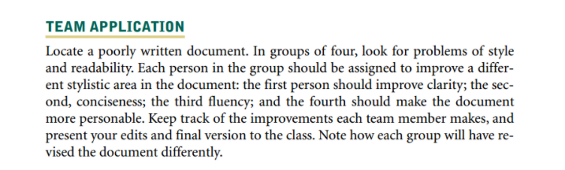

Discussion 7.1
Please use this opportunity to ask questions regarding content that you had difficulty with for the midterm exam.
Remember to cite your sources, defend your position with evidence from credible sources,

Discussion 9.1
Go to p. 158 of your textbook and, in a discussion post, complete the requirements in the “Team Application” section.
Remember to cite your sources, defend your position with evidence from credible sources,
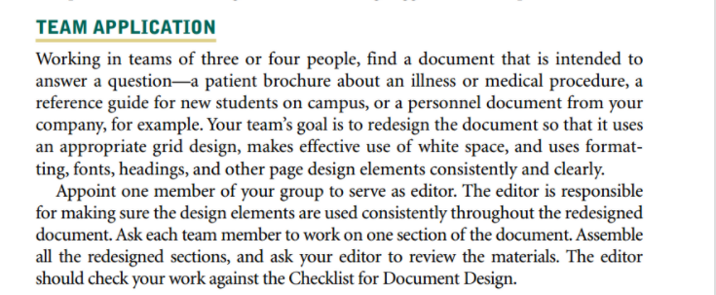

Discussion 9.2
Review the labeling of a painkiller or cold medication. What purpose or purposes does this communication serve, and for whom? How well do the design decisions on the label serve the audience(s) and purpose(s) you’ve identified? What design strategies might make this even more effective, given the space limitations that are inherent in a label? Post your findings in a discussion post.
Remember to cite your sources, defend your position with evidence from credible sources,

Discussion 10.1
Select one of the following types of employment messages and conduct research on how to make the message effective:
- A résumé
- An application letter
- A specific type of follow-up message
Post your response to the following on the discussion board. If appropriate, include personal experience as part of your answer.
- Provide a brief statement that paraphrases the results of your research. Include the source of your research and indicate the type of employment message you selected.
Remember to cite your sources, defend your position with evidence from credible sources,

Discussion 11.1
Working in pairs, evaluate the design and organizational structure of a memo from a workplace. This could be a memo currently used in one of your own companies or organizations, or one you obtain from someone else with access to workplace documents. Be sure this is the type of memo you can share outside the company or that you have permission to do so with specific names redacted.
To what degree does the memo include the basic parts and format indicated in your readings in Chapter 11?
- How appropriate is the tone?
- Does it take a direct or indirect approach, and was the choice appropriate?
- Overall, how effective is the memo? What changes might make it more effective?
- Does the memo fall within one of the basic types of memos presented in the chapter, or is it another type of memo?
Post your findings in a discussion post.
Remember to cite your sources, defend your position with evidence from credible sources,

Assignment 7.1
Please add content related to the Midterm Project.
When you have completed the assignment, save a copy for yourself in an easily accessible place and submit a copy to your instructor using Dropbox.

Assignment 9.1

Web-Based Collaborative Document Design
Increasingly, documents are being created via Web-based word processing programs that are often available for free and easily accessible to distributed teams (e.g., Google docs). Compare the document design features available in one of these Web-based tools with those of your own desktop-based software. Evaluate the ease and effectiveness of the Web-based option for creating well-designed documents.
Write a two-page paper detailing your findings.
When you have completed the assignment, save a copy for yourself in an easily accessible place and submit a copy to your instructor using Dropbox.

Assignment 9.2

Memo
Go to p. 157 of your textbook and complete the requirements in the “General Application” section. You may do the assignment as individuals and are not required to partner with someone.
When you have completed the assignment, save a copy for yourself in an easily accessible place and submit a copy to your instructor using Dropbox.
upon successful completion of this lesson, students should specifically be able to do the following:
- Describe the importance of document design.
- Identify and create well-designed documents.
- Use design elements for consistency and coherence.
- Use design elements for navigation and emphasis.

Assignment 10.1

Résumé, Application Letter & Thank You Letter
Search the Internet for at least three sample résumés for a position similar to one you would like to obtain. Use the examples to help build or refine your résumé, using the samples you found as a guide. Keep in mind, everything you have learned about resumes today. Additionally, you should prepare a cover letter for the desired position along with a thank you letter written after your interview.
For those of you who have Linkedin accounts, please review them and provide a link in our Discussion 10.2. For those of you who do not have an account, please create one and post a link for your classmates to view.
Home | NextAdvisor with TIME
Motto | Time
Upon successful completion of this lesson, students should specifically be able to do the following:
- Research jobs and narrow their job search.
- Create hard copy and electronic résumés.
- Write a persuasive job application letter.
- Compile a dossier and a Webfolio (or Webfolio).
- Prepare for job interviews.
- Write an appropriate thank you letter.
- Write an appropriate acceptance or refusal letter.

Assignment 11.1

Email
Read the following scenario: You enjoy your duties as manager of the women's sportswear division at Macy's, Florida. You especially enjoy being able to recommend someone for a promotion. Today, you received an email message from Rachel Cohen, head buyer for women's apparel. She is looking for a smart, aggressive employee to become assistant buyer for the women's sportswear division. Macy's likes to promote from within, and Rachel is asking all managers and supervisors for likely candidates. You have just the person she's looking for.
Jennifer Ramirez is a salesclerk in the designer sportswear department of your main store in Miami, and she has caught your attention. She's quick, friendly, and good at sizing up a customer's preferences. Moreover, at recent department meetings, she has shared some insightful observations about fashion trends in south Florida.
Write an email reply to Rachel Cohen, head buyer, women's sportswear, recommending Jennifer Ramirez and evaluating her qualifications for the promotion. Rachel can check with the human resources department about Jennifer's education and employment history; you're mainly interested in conveying your positive impression of Jennifer's potential for advancement. Attention should be given to message appropriateness, correct format, and professionalism of the letter. Please be sure to proof your work as grammatical errors and lack of professional tone may affect their decision. The ball is in your court to get this promotion for Ms. Ramirez.
When you have completed the assignment, save

Professional Correspondence - part1 -Letters, memos, and email, oh my! - YouTube
Communicating Routine Information (pearsoncmg.com)

Upon successful completion of this lesson, students should specifically be able to do the following:
Identify the parts and format of a workplace memo.
Achieve the right tone in a memo or letter.
Determine when to take a direct or indirect approach in a memo or letter.
Write an effective memo.
Write an effective inquiry, claim, sales, or adjustment letter.

Read Chapter 11 from your textbook. Please click on the eText link within the Class Information block.
View the lecture material.
Participate in the discussion.
Complete the assignment.
Submit the quiz.

